**Local 776 Newsletter**

**August 2025 Newsletter Issue #234**

**Labor Day Parade**

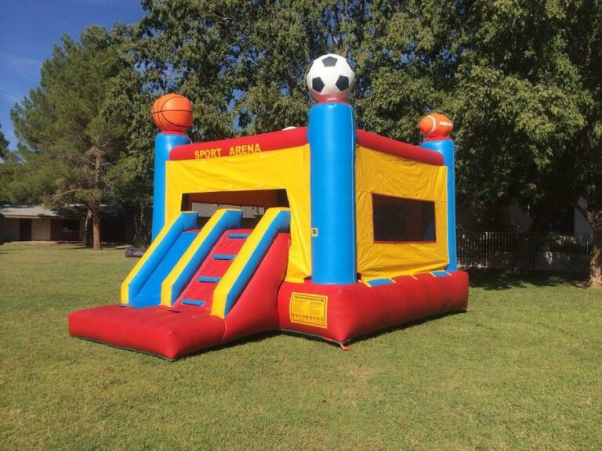

[This Photo](https://www.gardentoolexpert.com/can-you-use-a-leaf-blower-for-a-bounce-house/) by Unknown Author is licensed under [CC BY-SA](https://creativecommons.org/licenses/by-sa/3.0/)

Monday September 1st

Meet in the Northland Shopping Center parking lot at 8:30 am

No need to sign up, just bring your family and walk with us!

Shirts will be provided, Picnic at the hall to follow

**SPECIAL NOTICE SPECIAL NOTICE SPECIAL NOTICE**

**The unfilled office positions for the Examining Board and Finance Committee ran uncontested and therefore will not require a vote. Also, the delegates for the State Building Trades Convention were uncontested, therefore not requiring a vote. There will not be an August Secret Ballot Vote.**

**Fraternal News**

* **Death Benefit:** We are on Death Benefit #378 Larry Price. Death Benefits can be paid over the phone, in person or online at [www.ualocal776.com](http://www.ualocal776.com).
* **Welcome:** Joshua Hicks, Kayden Cottrell, Kyle Lathrop, Mark Steele and Jaime Arreola. These new members were sworn in at July’s union meeting. If you are working with any of them, please welcome them into Local 776!

**Future Events to put on the Calendar**

* **Union Meeting:** Wednesday August 20th, 2025 at 7pm
* **UA Weld Test:** Saturday August 23rd, 2025 at 8 A.M.

Please call Melissa no later than noon the Thursday before to sign up and to check on the status of the test session.

* **Summer Picnic:** The Local 776 Summer Picnic is scheduled for August 16th from 12-4 at Winona Lake. Come out to enjoy the sun with your family! Please call the hall to sign up before the end of business on August 8th if you plan to attend.
* **Labor Day:** We will once again be walking in the Lima Labor Day Parade on September 1st.We will be meeting at 8:30 am to hand out shirts at the Northland Shopping center. We will follow up with a cookout at the Local 776 Union hall. We will also have a bouncy house for the kids to enjoy. Please come out and show your union spirit and walk with us! Wives and children are encouraged to attend as well!

**JATC**

* **Classes are out for the Summer!** The first night of class this fall will be Tuesday September 2nd, 2025 for Building Trades and Commercial Plumbers beginning at 6pm. The first night of class for the MES will be Wednesday September 3rd beginning at 5pm. Food will be provided both nights!
* **Classes:** The JATC will be coming out with some new classes that are open to the entire membership including mental health awareness. Please keep your eyes out for these announcements if you are interested in attending.
* We have sent out recertification notifications for Rigging and medical gas and back flow, if you are coming up for recertification and have not received notification, please contact us.

**BACK PAGE**

**Business Manager Comments**

Labor Day is a good time for everyone to appreciate what previous union members have fought for to build up what we have today. Because of organized labor we have things such as the 8-hour workday and 40-hour week. Laws like this not only strengthen the union, but they raise the bar making everyone’s lives better. So, on Labor Day make sure you kick back and enjoy your day off knowing that what unions today are fighting for are making a difference for everyone.

Brad

**Chewy’s Corner**

I am unable to come up with a subject to talk about so,

Make that money and them pension credits

-Chewy

Fraternally, In Solidarity,

Brad P. Wendel Nick Butorac

Brad P. Wendel Nick Butorac

Business Manager/ Financial Secretary – Treasurer Business Agent