Local 776 Newsletter
August 2026 Newsletter Issue #246

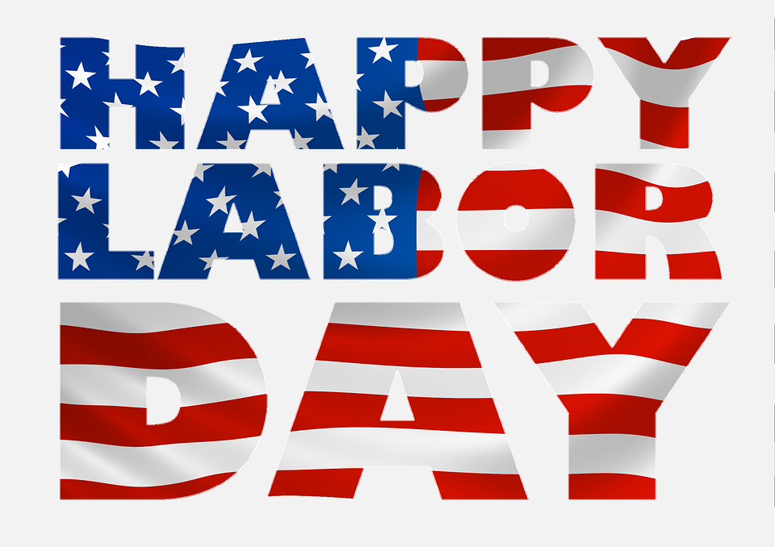

Labor Day Parade
This Photo by Unknown Author is licensed under CC BY-SA
Monday September 7th
Meet in the Northland Shopping Center parking lot at 8:30 am
No need to sign up, just bring your family and walk with us!
Shirts will be provided, Picnic at the hall to follow

Fraternal News
- Death Benefit: We are on Death Benefit #383 James Sylvia. Death Benefits can be paid over the phone, in person or online at www.ualocal776.com.
- Welcome: Kaden Merritt, Dustin Waldroop, Joseph Cummins, Isaac Grundisch, Samuel Hoagland, Michael Scarberry, Avery Freudenberg, Charles Hamblin, Aiden Howard, Anaira Harris, Levi Schroeder. These new members were sworn in at July’s union meeting. If you are working with any of them, please welcome them into Local 776!
Future Events to put on the Calendar
- Union Meeting: Wednesday August 26th, 2026 at 7pm
- August Union Meeting: The August Union meeting is being moved to August 26th, which is a week later than the normal date due to the UA National Convention during the week of the normal meeting.
- UA Weld Test: Saturday August 22nd, 2026 at 8 A.M.
Please call Melissa no later than noon the Thursday before to sign up and to check on the status of the test session.
- Labor Day: We will once again be walking in the Lima Labor Day Parade on September 7th. Keep your eyes out for the August Newsletter for more information about what time to show up. We will follow up with a cookout at the Local 776 Union hall.
JATC
- First Night of Class: The first night of class will be Tuesday September 1st. This will be orientation for everyone to attend. There will be a cookout and food will be provided.
- Recertifications: The JATC will be sending out notifications for anyone needing a recertification. Please respond in a timely manner.
Business Manager Comments
I look forward to seeing everyone at the Labor day parade. Please make sure you are in the Northland parking lot at 8:30 so we can pass out shirts and line up around 9. If you cant walk in the parade, please feel free to come out to the cookout at the hall afterwards!
Chewy’s Corner
On top of finding folks, I have been tasked on working at changing our drug test system away from DISA, We are optimistic we may be able to implement it the beginning of 27 but we will see how it goes. Also, have very slowly working on Online dispatch, which would be an app on your phone where you could sign the list, check your position on the list, check certs, pay death bennies and take calls off of your phone, just to name a few. Have any questions about the previous get with me.
Chewy

Fraternally, In Solidarity,
Brad P. Wendel Nick Butorac
Brad P. Wendel Nick Butorac
Business Manager/ Financial Secretary – Treasurer Business Agent

